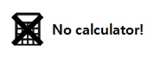
Index Laws Homework
Literacy  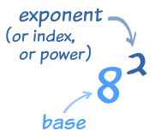 | Research  What is the value of $0^{2}?$  What is the value of $0^{-2}?$  What is the value of $0^{0}?$ | Memory  Learn these rules:  $$x^{a}×x^{b}=x^{a+b}$$  $$x^{a}÷x^{b}=x^{a-b}$$  $${\left(x^{a}\right)}^{b}=x^{ab}$$  $$x^{0}=1$$
Skills  Use index laws to simplify:  - $p^{2}×p^{5}$ - $p^{12}÷p^{4}$  - ${\left(p^{3}\right)}^{7}$ - $p^{0}×q^{3}$  - ${3p}^{4}×{5p}^{2}$ - $6pq^{3}×{2p}^{9}q^{2}$  - $\frac{p^{7}}{p^{2}}$ - $\frac{{8p}^{11}}{{2p}^{9}}$  - ${\left(2p^{4}\right)}^{3}$ - $\frac{{8q}^{2} × 3q^{7}}{{6q}^{8}}$ |  | Stretch  Find the value of:  - $2^{20}÷4^{10}$  - ${\left(2^{6}\right)}^{2}÷4^{5}$  - $3^{7}÷9^{3}$  - ${27}^{5}÷3^{12}$

