Areas of circles and sectors
Literacy – Write the definition of each word. Draw two examples and one non-example.  Radius  Diameter  Sector | Research  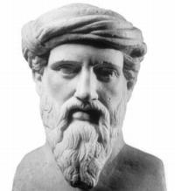  “What did the Greeks think of circles?” | Memory - Write down the formulae for:  Area of a circle  Area of a sector
Skills  For each of the circles, semi circles, sectors and shaded parts below find their area.  Round your answers to 1 decimal place.  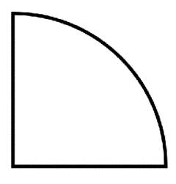  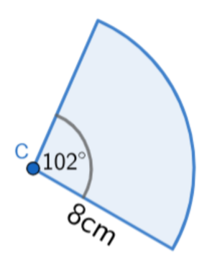  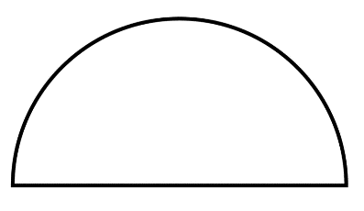  5cm  12cm  73°  103°  8.5cm  28m  15m  8cm  3cm  12cm  7cm |  | Stretch  A circle has a radius 6cm with centre O. A and B are points on the circumference such that angle AOB is 30°. Show that the area of sector AOB is exactly $3π$.  Find the size of the  angle, $θ$, if the  sector area is  $$θ$$  7cm m  10.7cm²  Find the length of  the radius, r, if the  sector area is 32cm²  58°  r

