**Memory**

To describe an enlargement you must state:

1. The scale factor
2. The centre of enlargement

**Research**

How is the volume of a shape affected by an enlargement of a scale factor of 2?

How are angles affected by enlargements?

**Literacy**

Scale factor

Centre of enlargement

Transformation

**Stretch**

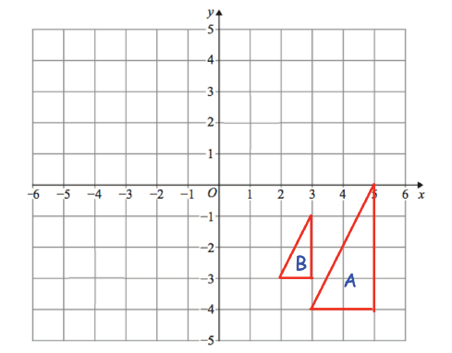

**Skills Practice**

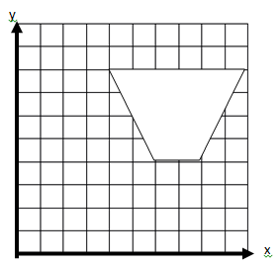

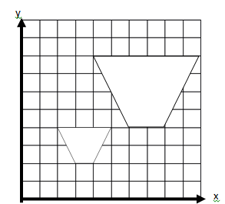

1

Enlarge the trapezium by a factor of  from the origin.

2

Triangle B is an enlargement of triangle A.

1. What is the scale factor of enlargement?
2. Work out the Centre of enlargement
3. Work out the area of triangle A and triangle B
4. Write down the ratio of the area of triangle A to the area of triangle B, in its simplest form.
5. What is the area scale factor for the enlargement?

Find the centre of enlargement and the scale factor that has transformed shape a into shape b

a

b