**Memory**

Revise vectors and their relationship with translation

**Research**

How is the volume of a shape affected by an enlargement of a scale factor of 2?

How are angles affected by enlargements?

**Literacy**

Scale factor

Centre of enlargement

Transformation

**Stretch**

Enlarge the trapezium by a factor of  from the origin.

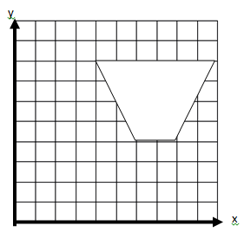

Find the centre of enlargement and the scale factor that has transformed shape a into shape b

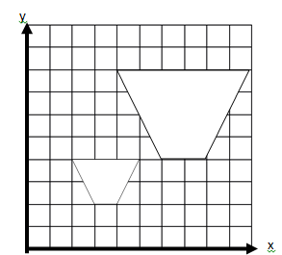

**Skills Practice**

You will need to draw a -10 to 10 axis for each question

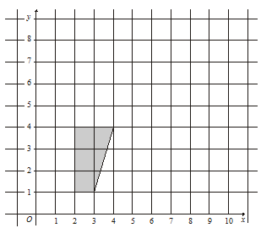

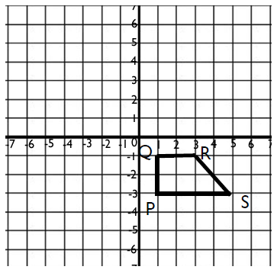

Enlarge the shape with;

1. a scale factor of 2 and a centre of enlargement (1, 1)
2. a scale factor of 2 and a centre of enlargement (7,6)

1

2

Enlarge the trapezium with a scale factor of 2 and a centre of enlargement (5,-3)

a

b