Area of a Circle
Literacy  Chord Tangent  Sector Segment | Research  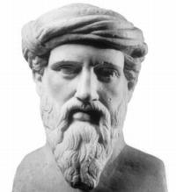  “What did the Greeks think of circles?” | Memory  $$A=πr^{2}$$  $$C=πd$$
Skills  For each of the circle, semi circles and quarter circles below find their area. Round your answers to 1 decimal place.  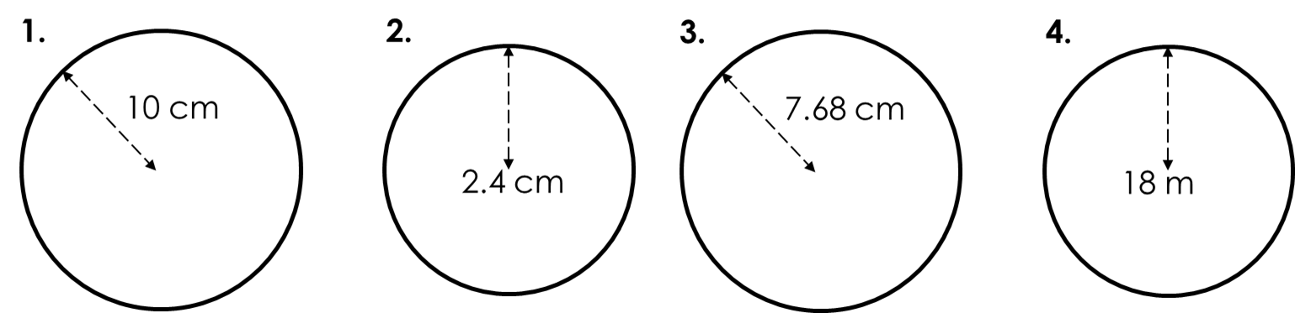  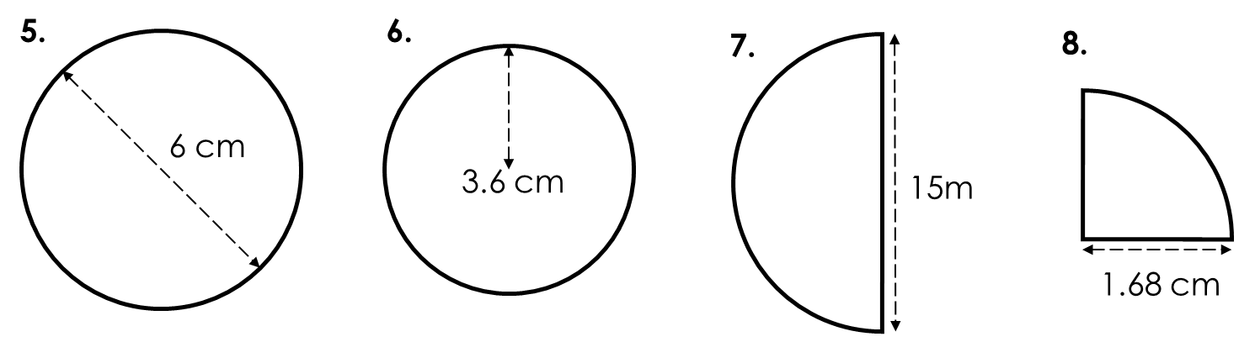 |  | Stretch  A circular pond is surrounded by paving. The pond has a radius of 1m and the paving has a radius of 2m. Find the area of paving rounded to 1 decimal place.  