**Memory**

Revise the angle facts about angles along a straight line, around a point, in a triangle and in a quadrilateral

**Research**

What are interior and exterior angles?

What do the angles in a hexagon and an octagon add up to?

**Literacy**

Vertically Opposite

Alternate

Corresponding

Supplementary

**Stretch**

Find the size of these missing angles

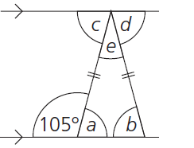

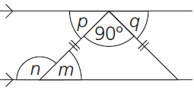

**Skills Practice**

Find the size of the missing angles, showing your working and the reason why?

